ITOps AI — Project Roadmap
Oct 7, 2026 · @hikmatullah shinwari

Overview
ITOps AI — Intelligent IT Service Desk & Endpoint Automation Platform — is a realistic internal IT operations product: AI-powered support, automated remediation, identity lifecycle management and intelligent ticket operations, built on Microsoft 365 and Azure.
An employee describes an IT problem in a web portal. The platform then:
- Creates the ticket.
- Uses AI to understand, categorize and prioritize it.
- Decides whether it is one of the supported automations.
- Runs the approved remediation when it is.
- Verifies the problem is actually fixed, then resolves the ticket.
- Escalates to the right IT team, with an AI summary, when automation fails or isn't supported.
- Gives technicians AI troubleshooting from an approved knowledge base.
- Gives IT managers operational analytics.
It also runs employee onboarding and offboarding, completing the Joiner → Leaver lifecycle.
Design principle. The goal is not to automate all IT support. V1 has exactly 10 predefined automated scenarios; everything else gets AI triage and a human technician. New automations (for example VPN remediation) can be added later as #11 without redesigning the system.
Why it matters for the target roles. It shows hands-on Entra ID, Intune, Microsoft Graph, Power Automate, Azure Functions, monitoring and security work — the daily tools of IT Support, Desktop Support and endpoint roles — plus responsible use of AI.

Architecture
The web portal is the front door; the real product is the automation platform behind it.
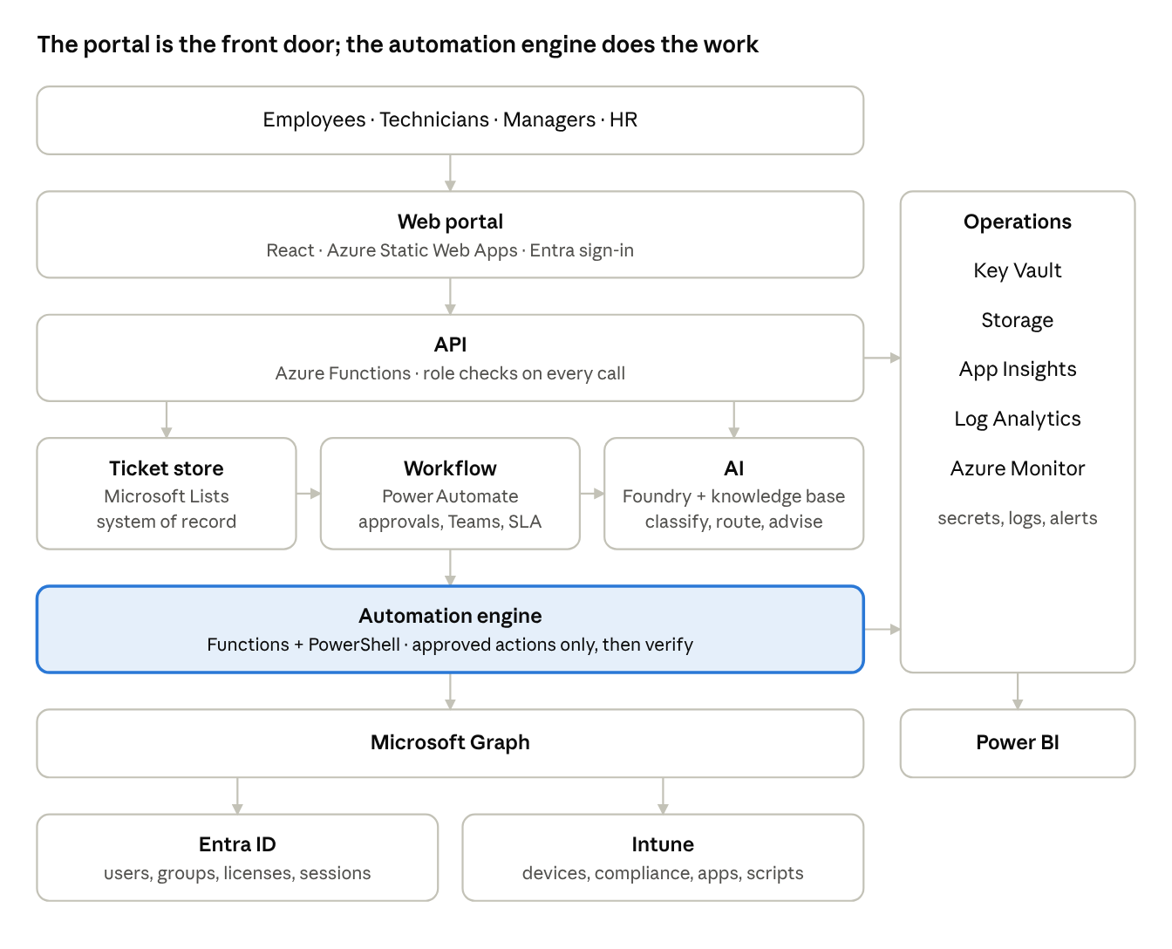
architecture · portal to Microsoft services
Requests flow top to bottom; the API and automation engine send telemetry to the operations layer, which feeds Power BI.
Layer | Technology | Job
Web portal | React on Azure Static Web Apps, Entra sign-in | Employees submit and track tickets, search the KB; technicians work the queue; managers approve and watch the dashboard
API | Azure Functions (Python) | The only thing the portal talks to; reads and writes tickets, enforces roles
Ticket store | Microsoft Lists (SharePoint) | IT Tickets list, the system of record
Workflow | Power Automate | Approvals, Teams notifications, SLA timers, escalation
AI | Microsoft Foundry | Classification, priority, routing, automation decision, technician assistant, resolution summaries
Knowledge base | 20–30 approved articles (RAG) | Grounds the AI's troubleshooting advice
Automation engine | Azure Functions + PowerShell | Runs only the approved remediation for a selected scenario, then verifies it
Microsoft services | Entra ID, Intune, Microsoft Graph | Identity actions, device status, sync, compliance, app installs, remediation scripts
Operations | Key Vault, Storage, Application Insights, Log Analytics, Azure Monitor | Secrets, files, telemetry, central logs, alerts
Analytics | Power BI | Service desk, AI, automation and endpoint reporting
AI safety boundary. AI never has unrestricted admin access. It recommends a category and an approved scenario; the predefined workflow decides and the known PowerShell or Function executes, then verification checks the result. AI cannot decide on its own to disable an account — only an approved offboarding request can trigger that.

The 10 automated scenarios
Every scenario follows the same pattern — Detect → Validate → Automate → Verify → Resolve or Escalate — so a failure always lands with a human.
# | Scenario | Example request | What the automation does | If it fails
1 | Account locked | "It says my account is locked." | Confirms the lockout in Entra, runs the approved unlock or guided reset, checks sign-in works | Help Desk
2 | Password / SSPR assistance | "I forgot my Microsoft 365 password." | Checks SSPR registration, guides the user through Microsoft's own reset | Help Desk
3 | Low disk space | "My laptop is very slow." | Checks disk in Intune; under 10% free, runs a cleanup script and rechecks | Endpoint
4 | Device not checking in | "My laptop isn't getting company policies." | Finds a stale check-in, triggers an Intune sync, checks again | Endpoint
5 | Device compliance | "My device says it's not compliant." | Finds the failing rule, AI explains it, applies the approved fix, re-evaluates | Endpoint
6 | Approved software install | "I need 7-Zip installed." | Checks the catalog (7-Zip, Chrome, VLC, Adobe Reader, Teams), gets approval if needed, deploys, verifies | Endpoint
7 | Teams basic support | "Teams isn't working properly." | Checks service status, clears the Teams cache, verifies | M365
8 | Outlook basic troubleshooting | "Outlook isn't opening." | Checks known conditions, runs the approved cache or service fix, verifies | M365
9 | Employee onboarding | HR form for a new hire | Manager approval, account, groups, licenses, checklist, Teams notification | IT Operations
10 | Employee offboarding | HR form for a leaver | Approval, disable account, revoke sessions, remove access and licenses, device recovery checklist | IT Operations
Everything else is classified and routed, not automated. A printer problem goes to IT Support as Hardware P3; Wi-Fi to Network Support; a broken monitor to Hardware; a suspected phishing click to Security as P1/P2. The technician receives the ticket with an AI summary and suggested troubleshooting.

Roadmap at a glance
The portal comes first, then each stage plugs real services into it; the first end-to-end automation (M3) is the point where the project becomes interview-ready.
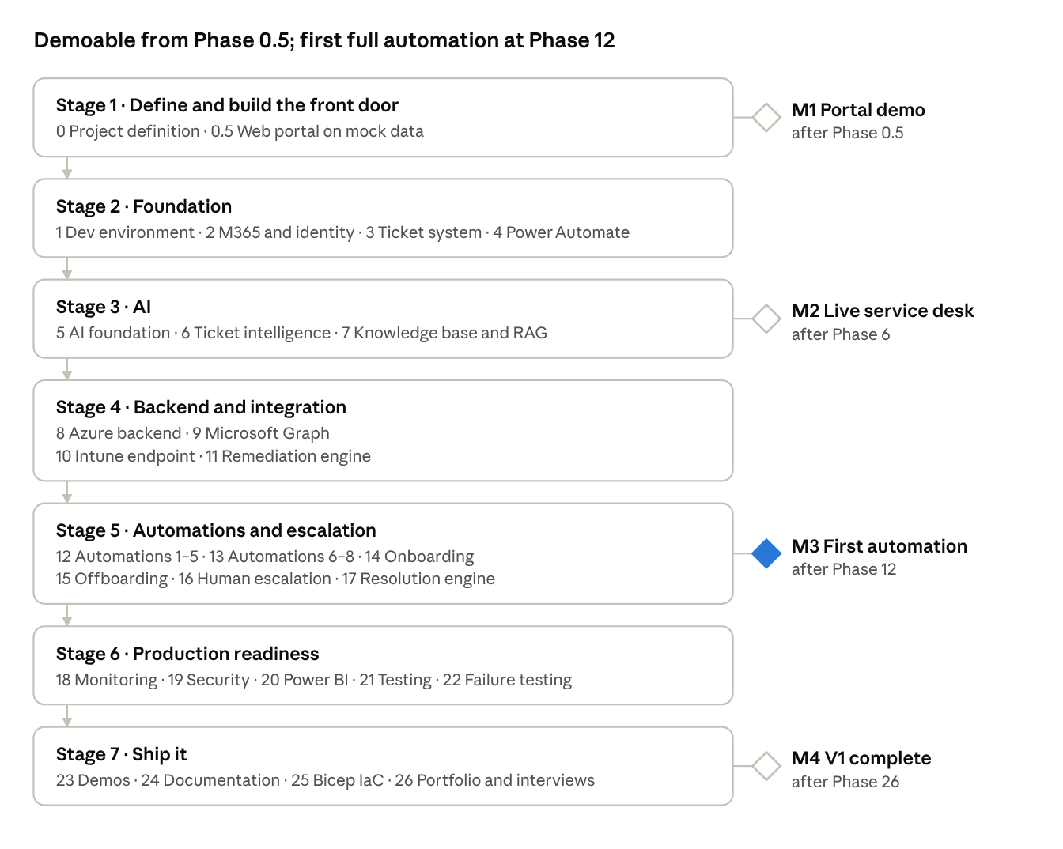
roadmap · 7 stages, 28 phases, 4 milestones
Stages run top to bottom; diamonds mark the four demoable milestones.

Phase by phase
Twenty-eight phases in seven stages; each stage ends with something that works and can be shown.

Stage 1 — Define and build the front door
Phase | Goal | Key work | Deliverable
0 — Project definition & architecture | Freeze scope before building | Objectives, architecture, roles, ticket lifecycle, the 10 scenarios, automated vs escalated, AI responsibilities, security boundaries, success criteria | Phase 0 Specification (requirements, architecture, data flow, lifecycle, automation matrix, security model)
0.5 — Web portal | Build the complete portal first | All screens for all roles against a mock API that returns the spec's exact data shapes: submit ticket, My Tickets, KB, technician queue and workspace, dashboard, approvals, HR forms, admin | Fully clickable portal; later phases plug in where needed

Stage 2 — Foundation
Phase | Goal | Key work | Deliverable
1 — Development environment | Everything needed to build | GitHub repo, Python, Azure CLI, Functions Core Tools, PowerShell, VS Code, Git, M365 test tenant, Azure subscription; repo layout (docs, architecture, azure, functions, powershell, ai, power-automate, knowledge-base, tests) | Clean, working dev environment
2 — M365 & identity foundation | A working test tenant | Entra ID, test users, groups (IT-Helpdesk-L1, IT-Endpoint-Support, IT-M365-Support, IT-Network-Support, IT-Security, IT-Management), admin accounts, Teams, SharePoint, Lists | Functioning M365 test environment
3 — Ticket management system | The service desk before AI | IT Tickets list with all fields; lifecycle New → AI Analysis → Triaged → Assigned → In Progress → Resolved → Closed | Working basic ticket system
4 — Power Automate core workflow | Automate the ticket lifecycle | Ticket creation, notify IT, status updates, Teams notifications, assignment, SLA timestamps, escalation notices | Service desk workflow without AI — so later breakages can be traced to AI or workflow

Stage 3 — AI
Phase | Goal | Key work | Deliverable
5 — AI foundation | Introduce Microsoft Foundry | Foundry project, model deployment, authentication, endpoint, prompt management; first classification output | Reliable AI classification service
6 — AI ticket intelligence | Full triage | Classification, P1–P4 priority, routing to team, automation decision, troubleshooting recommendation | AI-powered ticket triage
7 — Knowledge base / RAG | Grounded, not invented, advice | 20–30 approved articles (password reset, lockout, Outlook, Teams, performance, disk, Intune sync, compliance, software, Wi-Fi, onboarding, offboarding) | AI IT support assistant

Stage 4 — Backend and integration
Phase | Goal | Key work | Deliverable
8 — Azure automation backend | Secure backend | Resource group, Function App, Storage, Key Vault, Application Insights, Log Analytics; functions such as check_device, check_compliance, run_remediation, verify_remediation, update_ticket | Secure Azure automation backend
9 — Microsoft Graph integration | Reach M365 services safely | Users, groups, account status, device info, identity operations via managed identity / app permissions | Secure M365 API integration
10 — Intune endpoint environment | A real managed device | Windows 11 test VM enrolled; compliance policy, configuration, groups, remediation scripts; deliberately create low-disk, non-compliant and stale check-in conditions | Test endpoint controlled through Intune
11 — Automated remediation engine | The core engine | Ticket → AI selects an approved action → validate → execute known script/function → verify → update ticket; AI never runs arbitrary commands | Remediation engine

Stage 5 — Automations and escalation
Phase | Goal | Key work | Deliverable
12 — Automations #1–#5 | Identity and endpoint first | Account lockout, password/SSPR, low disk, device check-in, compliance | Five working automations
13 — Automations #6–#8 | Software and M365 | Software install, Teams basic, Outlook basic — deliberately limited | Three more automations
14 — Employee onboarding | Joiner workflow | HR request → approval → account, groups, licenses → checklist → Teams notice | Automated Joiner
15 — Employee offboarding | Leaver workflow | Approval → disable → remove access → revoke sessions → device recovery → notify → close | Automated Leaver
16 — Human escalation | Safe fallback | Not automatable or failed → AI technician summary → assign team → Teams notice | Every unsupported ticket reaches a human
17 — Ticket resolution engine | Tie it all together | Created → Analyzed → Triaged → Automation Selected → Validation → Remediation → Verification → Resolve or Escalate | Central operational engine

Stage 6 — Production readiness
Phase | Goal | Key work | Deliverable
18 — Monitoring & observability | Answer "why did this fail?" | App Insights (executions, errors, duration), Log Analytics (ticket, automation, AI events), Azure Monitor alerts (automation failure, high error rate, long-running and repeated failures) | Production-like monitoring
19 — Security | Harden everything | Entra auth, RBAC, least privilege, managed identity, Key Vault, secure API permissions, audit logs; roles Employee, L1, L2, IT Manager, Administrator | Security model implemented
20 — Power BI dashboard | Management view | Service desk, AI, automation and endpoint metrics | Final IT operations dashboard
21 — Testing | Positive and negative tests | For every scenario: success path and forced-failure path that escalates | Test matrix with results
22 — Security & failure testing | Fail safely | Unauthorized users, invalid requests, AI misclassification, API/Intune/Function outages, duplicate tickets, repeated automation, permission failures | Failure-mode results

Stage 7 — Ship it
Phase | Goal | Key work | Deliverable
23 — End-to-end demos | Show it working | 5–7 polished demos: low disk, compliance, Wi-Fi escalation, onboarding, offboarding, Outlook, automation failure → L2 | Portfolio videos and screenshots
24 — Documentation | Professional docs | README plus 14 documents: overview, requirements, architecture, AI, lifecycle, automation, Intune, identity, security, monitoring, testing, deployment, troubleshooting, demos | Documentation set
25 — Deployment & IaC | Reproducible Azure | Bicep (main, functions, storage, keyvault, monitoring), optional GitHub Actions CI/CD | One-command redeploy
26 — Portfolio & interview prep | Make it land with recruiters | Clean README and diagram, 3–4 resume bullets, LinkedIn showcase, interview Q&A | Interview-ready project

Milestones
Four milestones mark when the project becomes demoable; each is a gate before the next stage.
Milestone | Reached after | What you can show
M1 — Portal demo | Phase 0.5 | Every screen, every role, on mock data
M2 — Live service desk | Phase 6 | Real tickets in Lists, AI triage and routing, Teams notifications
M3 — First automation end to end | Phase 12 (low disk first) | Submit "laptop slow" → AI classifies → cleanup runs → verified → Resolved in the portal
M4 — V1 complete | Phase 26 | All 10 automations, escalation, monitoring, dashboard, docs, demos
How progress is measured
- ☐ AI accuracy on a labelled set of 100 sample tickets: category at least 85%, routing at least 80% (proposed targets).
- ☐ Each automation passes one success test and one forced-failure test.
- ☐ Every unsupported ticket reaches a human team with an AI summary.
- ☐ No secrets in the repository; permissions least-privilege and documented.
- ☐ Azure environment redeploys from Bicep.
Scope stays frozen at 10 automations for V1.

Open decisions
None of these block the portal; the first two must be settled before Phase 2. Details are in the Phase 0 Specification.
- Microsoft 365 tenant and licensing: Intune Remediations need Windows Enterprise E3/E5, and the Power Automate HTTP connector is Premium.
- Account lockout (#1): cloud-only Entra has no admin unlock — reframe as a guided reset, or add a hybrid on-premises AD lab for a real unlock.
- HR Requester role: a separate role, or IT Managers submit onboarding and offboarding.
- Proposed values: SLA targets, the reopen window and the AI confidence threshold.

